**STAT 40001/STAT59800 Statistical Computing Fall 2020**

**Lab-5**

1) The *Duncan* data frame has 45 rows and 4 columns. Data on the prestige and other characteristics of 45 U. S. occupations in 1950. The data is in the library car*.*

a) Access the data.

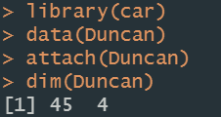

b) Print first five observations of the data set.

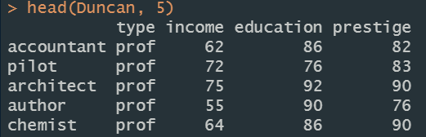

c) Use scatterplot to display the prestige scores according to the education level.



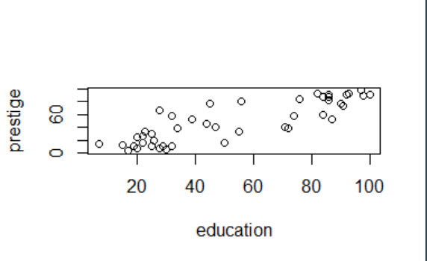

d) Change the color, title, labels etc. and save it.

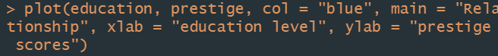

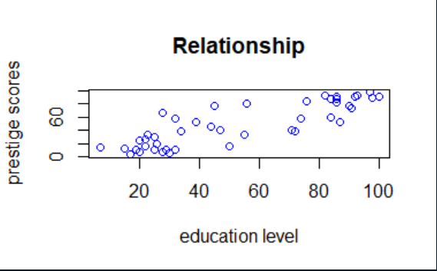

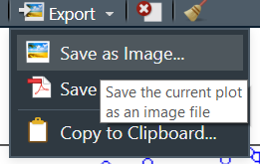

2) The Davis data in the car package contains data on the measured and reported heights and weights of 200 men and women engaged in regular exercise.

a) Access the data.

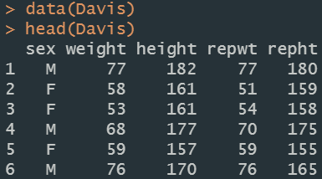

b) A few of the data values are missing and are marked as “NA”. Clean the data by deleting the missing values.

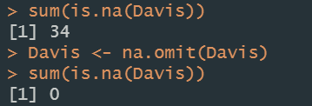

c) How many individuals do you have with complete information?



3) Access the data set “Elections” from ‘mdsr” package and extract the variable names included in the dataset.

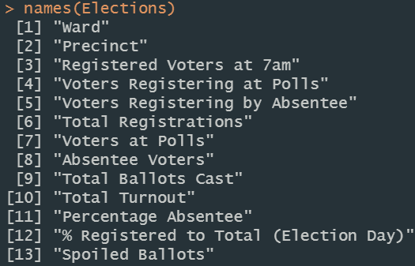

4) Link below provides a list of datasets related to economics (Data are from: principles of Econometrics)

<http://www.principlesofeconometrics.com/poe4/poe4stata.htm>

1. Import dataset entitled “savings” in R.



1. What is the dimension of the data?



1. Draw a histogram of the data related to the income. Please make sure to change the color, provide the title, labels etc.



